**Medical Inventory Management**

**College Name:** Sri Krishna Adithya College of Arts and Science College

**Code:** Bruag

**TEAM ID : NM2025TMID22782**

**TEAM MEMBERS : 4**

**TEAM LEADER NAME :** VIVITHA.M

**EMAIL:**23bsds164vivitham@skacas.ac.in@skacas.ac.in

**TEAM MEMBER 1** : AKALYA.M

**EMAIL**:23bsds104akalyam@skacas.ac.in

**TEAM MEMBER 2 :** AADISH.S

**EMAIL:** 23bsds101aadishs@skacas.ac.in

**TEAM MEMBER 3 :** RIZWANUEL NIHAS

**EMAIL:** 23bsds148rizwanuelnihas@skacas.ac.in

**Title** : **Medical Inventory Management**

**Project Overview**

The Medical Inventory Management System is a comprehensive Salesforce application designed to streamline and automate the operational aspects of managing medical stock. The system maintains detailed supplier information, manages purchase orders, tracks products and order transactions, and monitors expiry dates.

With the help of custom objects, fields, validation rules, triggers, flows, reports, and dashboards, the application ensures:

* Accurate supplier management – maintaining detailed records including contact details.
* Efficient product tracking – product catalog with descriptions, stock levels, pricing, and expiry dates.
* Transparent purchase order management – track order dates, deliveries, and costs.
* Strong reporting & insights – supplier performance, order cost analysis, and product tracking.
* Automation & efficiency – streamline workflows, reduce manual work, and minimize errors.

**Objectives**

* Streamline Inventory Management: Automate stock tracking, purchase orders, and supplier management.
* Enhance Accuracy: Monitor expiry dates, order costs, and delivery schedules to reduce risks.
* Improve Decision Making: Generate real-time reports on purchases, suppliers, and transactions.
* Ensure Transparency: Maintain detailed records of suppliers, products, and transactions.
* Promote Efficiency: Minimize delays in purchase order approvals and inventory movements.

**Student Outcomes**

* Hands-on Salesforce Experience: Students gain practical exposure in Salesforce CRM development.
* Understanding of Object Relationships: Learn how to model and relate inventory entities like Supplier, Product, Purchase Order, and Order Items.
* Data Validation Skills: Apply rules to ensure data integrity (e.g., delivery dates, stock levels).
* Real-Time Automation Exposure: Work with flows and triggers to automate inventory updates.
* Analytical Skills: Generate and analyze meaningful reports and dashboards.
* Industry-Relevant Knowledge: Exposure to CRM-based supply chain and inventory solutions.

**System Requirements**

**Hardware Requirements**

* Minimum 4 GB RAM, Dual-core processor
* Stable internet connection

**Software Requirements**

* Salesforce Developer Edition Org
* Modern Web Browser (Chrome / Firefox)

**Project Phases**

|  |  |  |  |
| --- | --- | --- | --- |
| Phase No. | Phase Name | Description | Pages |
| 1 | Requirement Analysis & Planning | Gather requirements from suppliers and staff; define scope and workflows. | 4 |
| 2 | Salesforce Development – Backend & Configurations | Create objects (Supplier, Product, Purchase Order, Order Item, Inventory Transaction), fields, and relationships. | 5–15 |
| 3 | UI/UX Development & Customization | Create Lightning App, Tabs, Layouts, and Compact Layouts. | 16–25 |
| 4 | Automation & Security | Implement Validation Rules, Profiles, Roles, Users, Permission Sets, Flows, and Triggers. | 26–40 |
| 5 | Reporting & Dashboards | Configure Reports, Dashboards, and analytics for supplier and order tracking. | 41–50 |
| 6 | Deployment, Documentation & Maintenance | Finalize app, test features, deploy, and prepare documentation. | 51–55 |

**Project Duration: 31 Hours**

**Project Flow (Milestones)**

**1. Creation of Developer Account**

* Sign up for a free Salesforce Developer Account at <https://developer.salesforce.com/signup>.
* Fill in details: First & Last Name, Email, Role = Developer, Company = College Name, Country = India, Postal Code = XXXX.
* Choose a Username in the format: username@organization.com.
* Click Sign Me Up → Check email → Verify account. 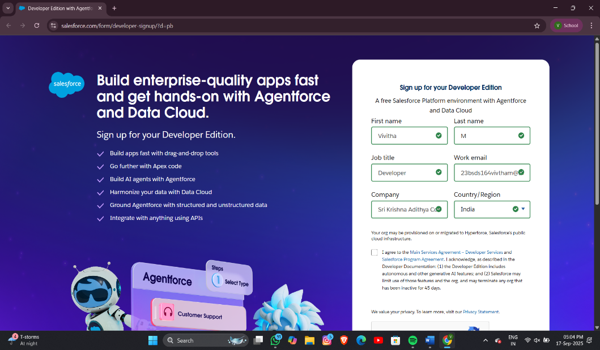
* Set password, security question → Login to Salesforce Org.

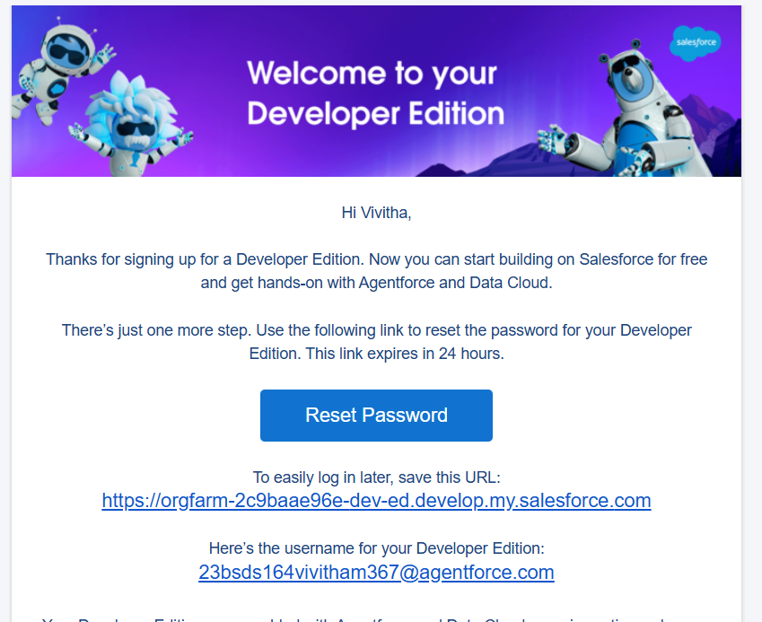

**2. Object Creation**

Objects are like database tables in Salesforce.

Custom Objects Created:

* Product → Product Name, Description, Unit Price, Expiry Date, Stock Level. 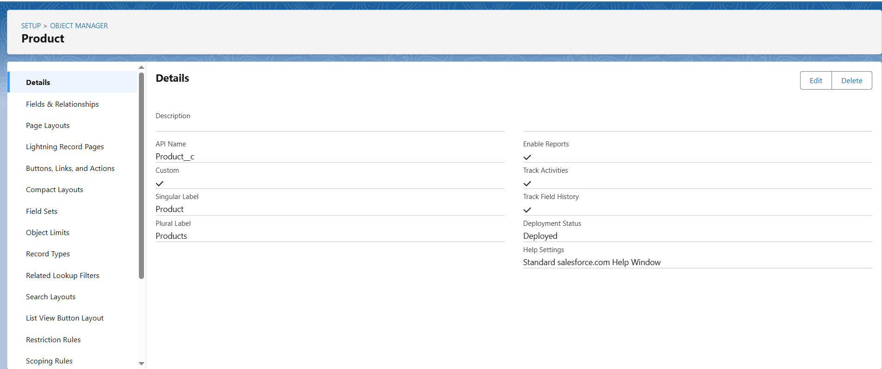
* Supplier → Supplier Name, Contact Person, Phone, Email.

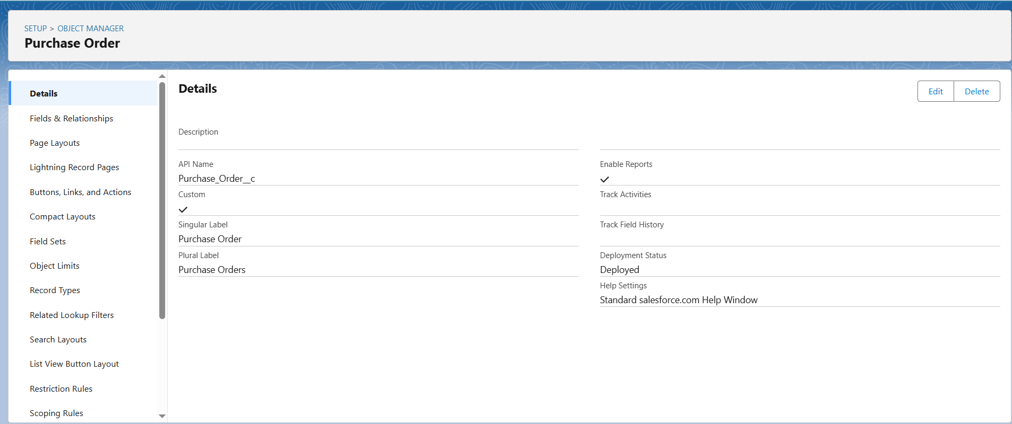

* Purchase Order → Supplier (Lookup), Order Date, Delivery Date, Total Cost.
* Order Item → Product (Lookup), Quantity Ordered, Amount.
* Inventory Transaction → Transaction Date, Type (Picklist: Issue/Receipt), Total Order Cost. 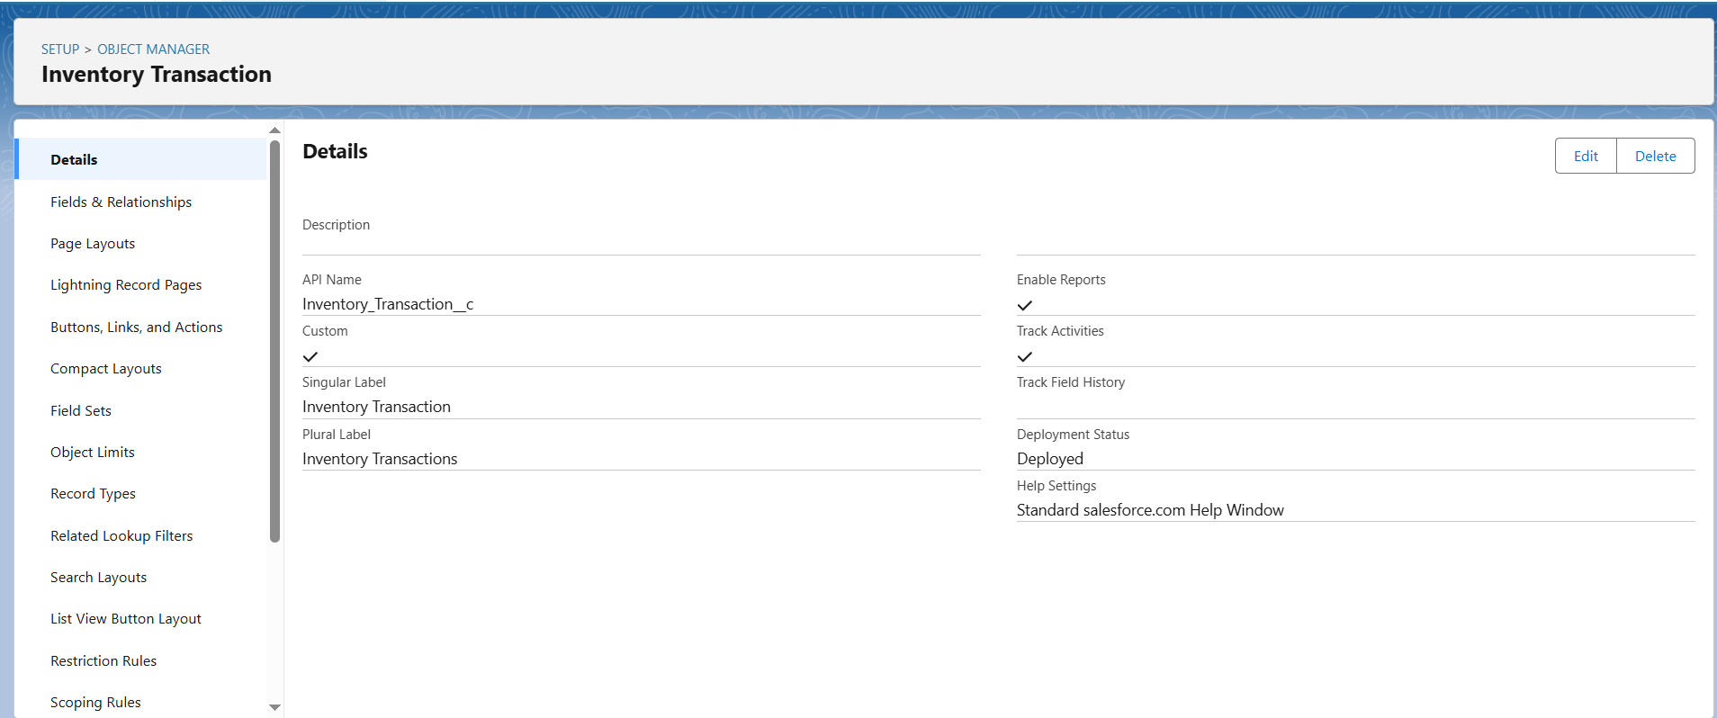

**3. Tabs**

* Create Tabs for each custom object to make them visible to users.
* Example: Product Tab → Setup → Tabs → New → Select Object → Choose Style → Save.
* Repeat for: Purchase Order, Order Item, Inventory Transaction, Supplier. 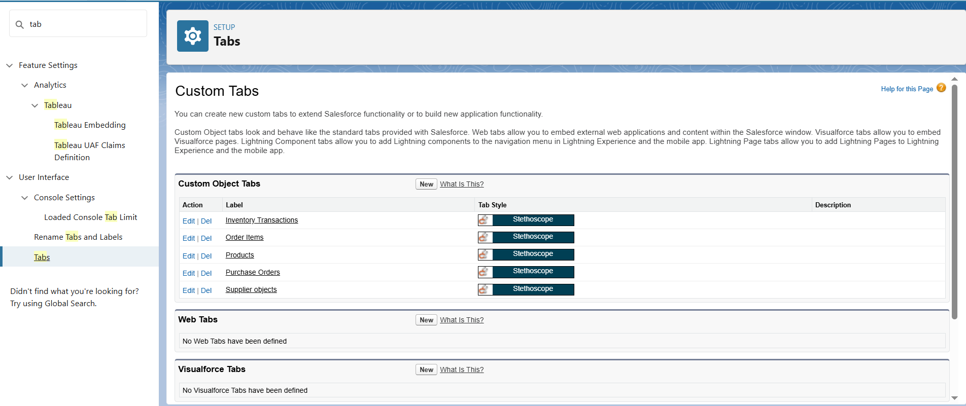

**4. The Lightning App**

* Go to Setup → App Manager → New Lightning App.
* Name: Medical Inventory Management.
* Add Navigation Items: Product, Supplier, Purchase Order, Order Item, Inventory Transaction, Reports, Dashboards.
* Assign to System Administrator → Save. 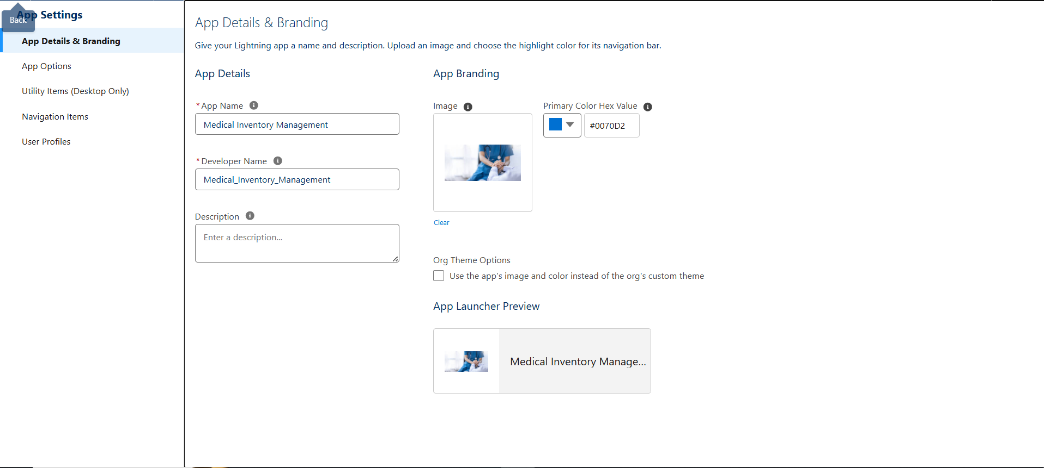

**5. Fields**

* Create fields for each object.
* Examples:
  + *Product*: Product Name (Text), Description (Text Area), Unit Price (Currency), Stock Level (Number), Expiry Date (Date).
  + *Purchase Order*: Order Date (Date), Supplier (Lookup), Total Order Cost (Currency).
  + *Order Item*: Quantity Ordered (Number), Unit Price (Formula), Amount (Formula).
  + *Inventory Transaction*: Transaction Type (Picklist: Issue, Receipt, Adjustment).

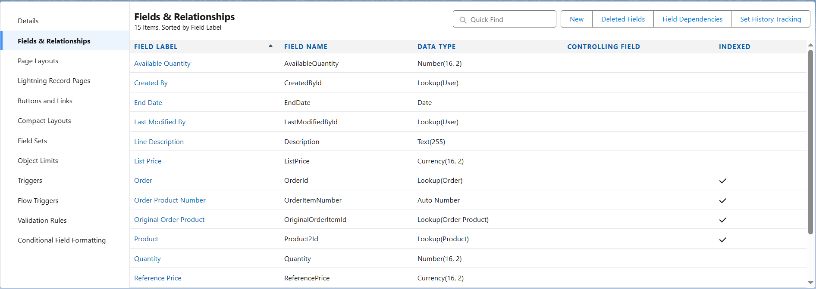

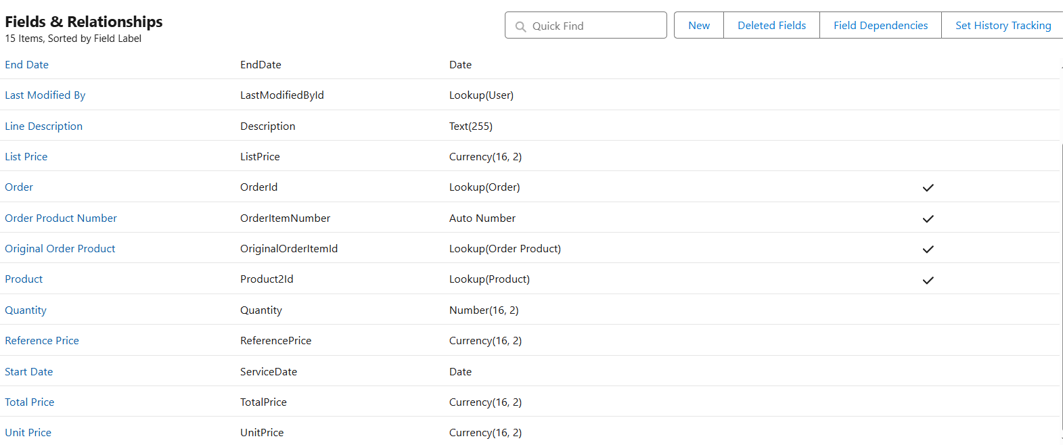

**6. Page Layouts**

* Customize layouts for each object. 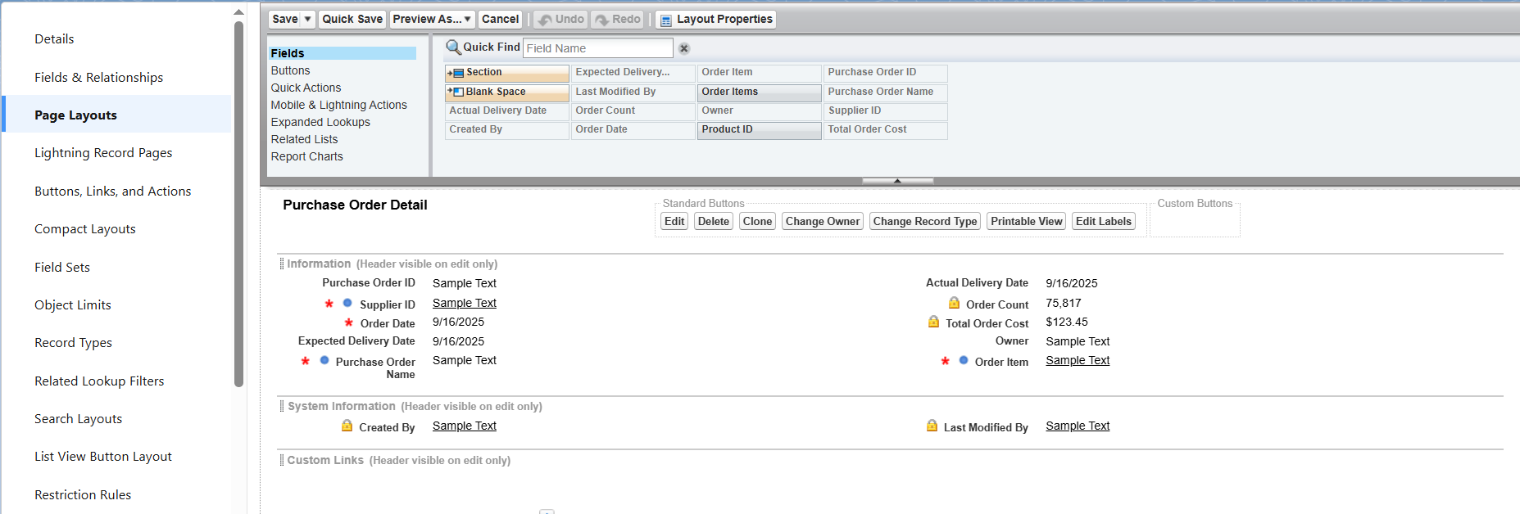
* Example: Purchase Order Layout → Make *Order Date* Required, *Total Cost* Read-Only. 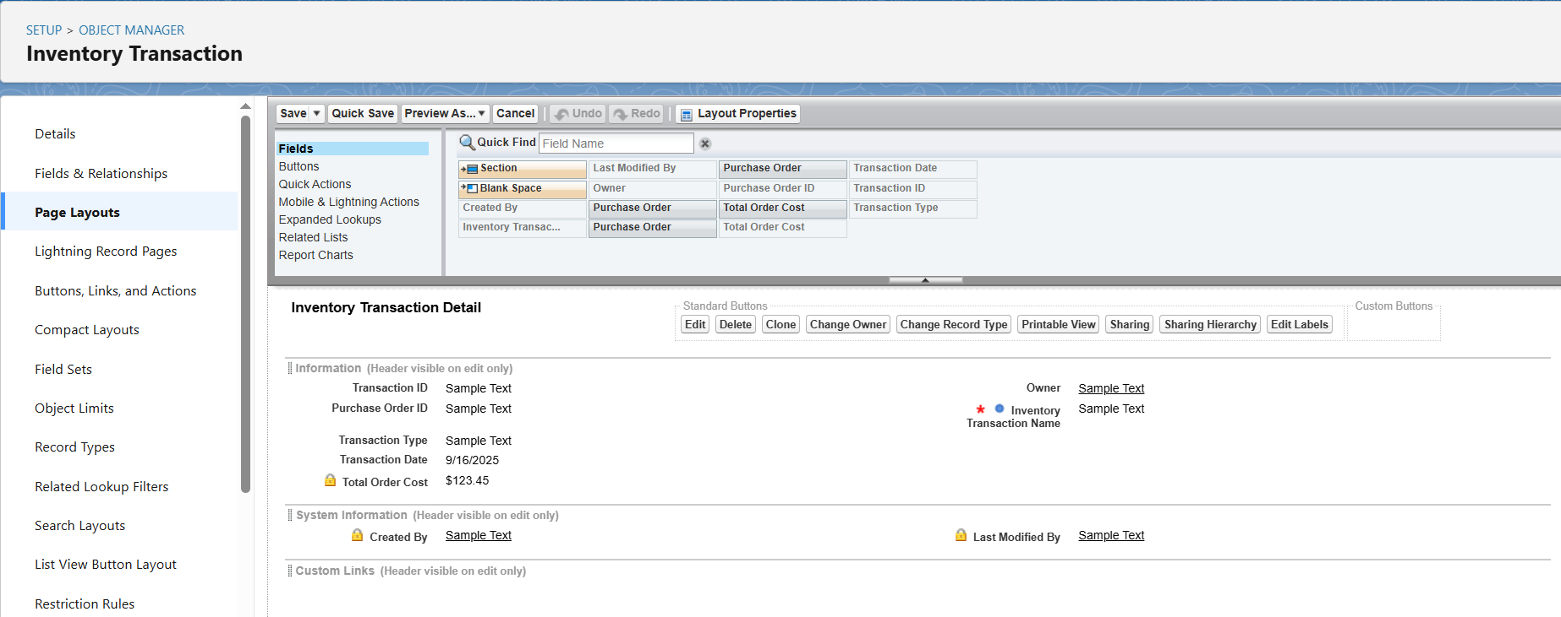
* Arrange related fields logically. 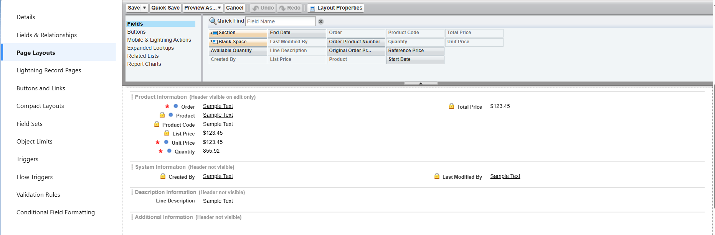

**7. Compact Layouts**

* Create Compact Layouts to show important fields at record highlights.
* *Product Compact Layout*: Product Name, Unit Price, Stock Level. 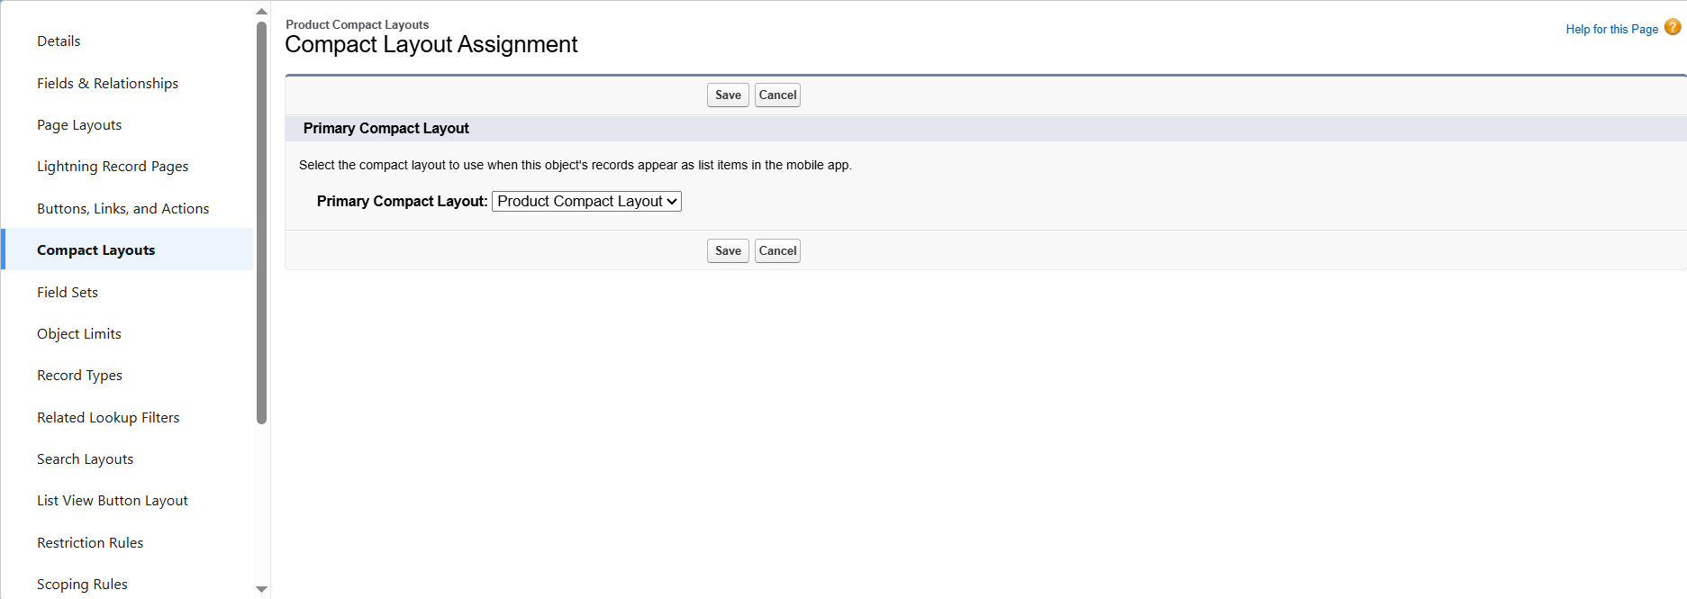
* *Purchase Order Compact Layout*: Order ID, Order Date, Supplier, Total Cost.

**8. Validation Rules**

* Add data quality rules. Example: Purchase Order Delivery Date Validation

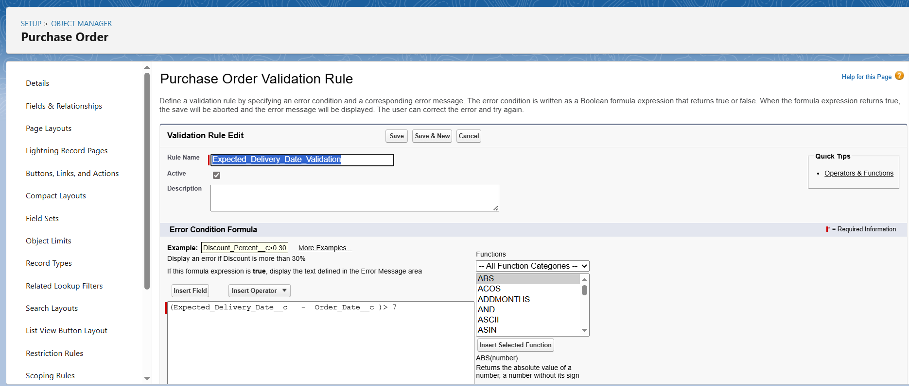 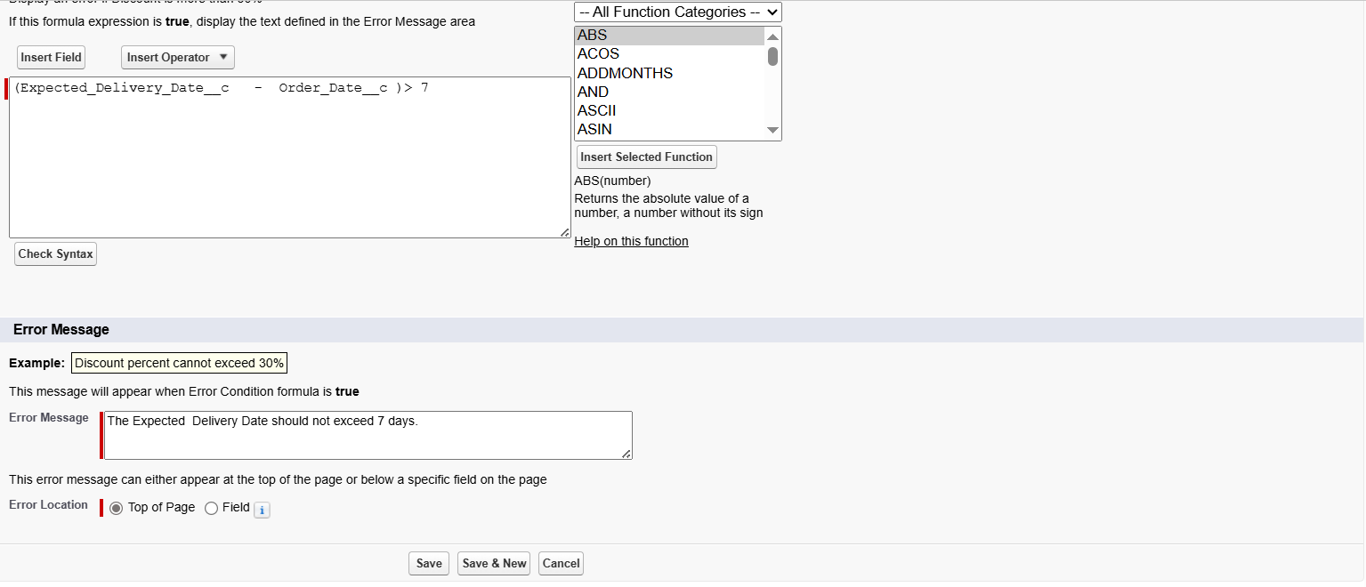

* (Expected_Delivery_Date__c - Order_Date__c) > 7

Error: *Expected Delivery Date cannot exceed 7 days.*

**9. Profiles**

* Define user permissions.
* Profiles Created:

Inventory Manager → Access to Product & Inventory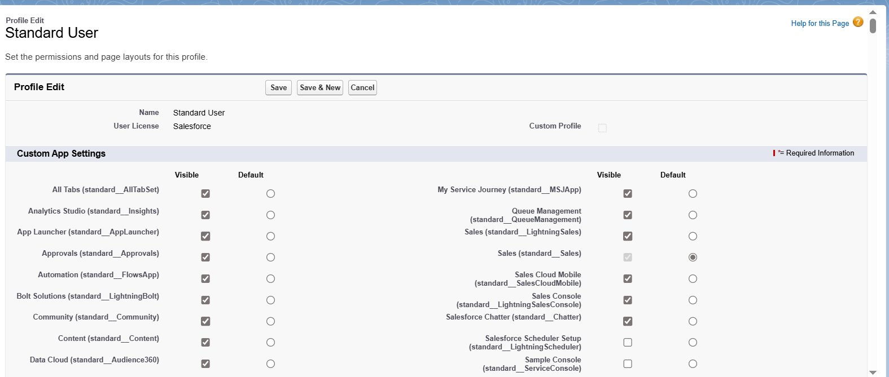 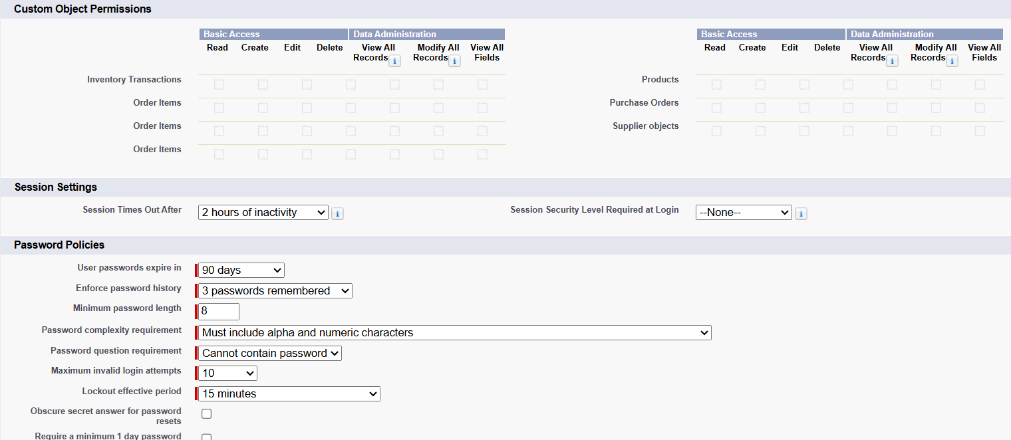

* + Purchase Manager → Access to Suppliers & Orders.

**10. Roles**

* Define record-level access.
* Roles Created:

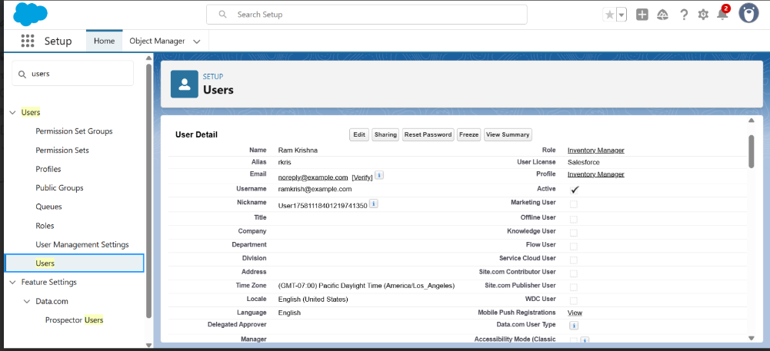

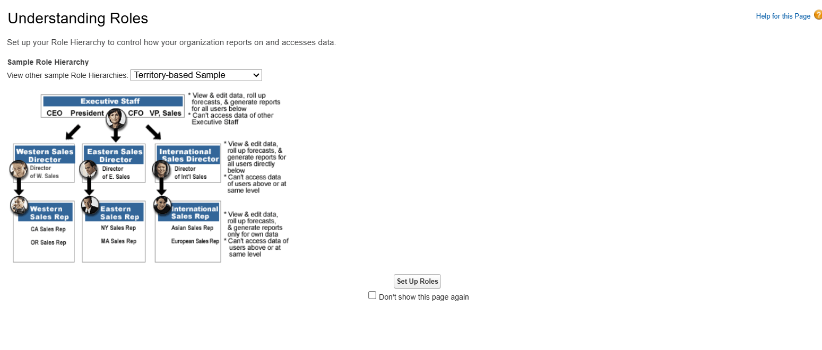

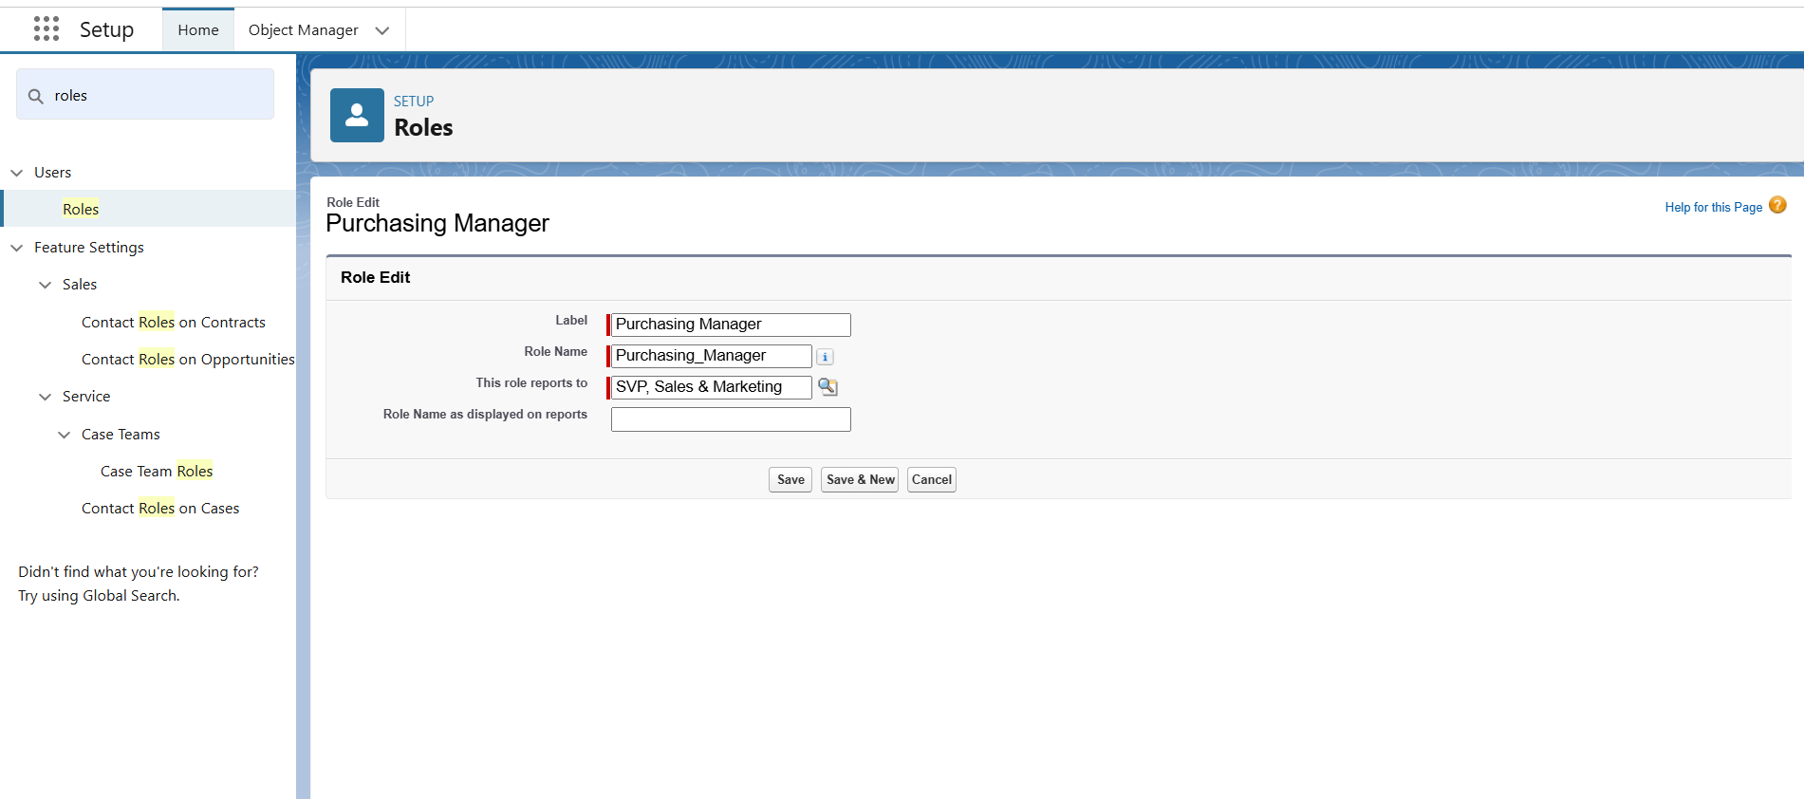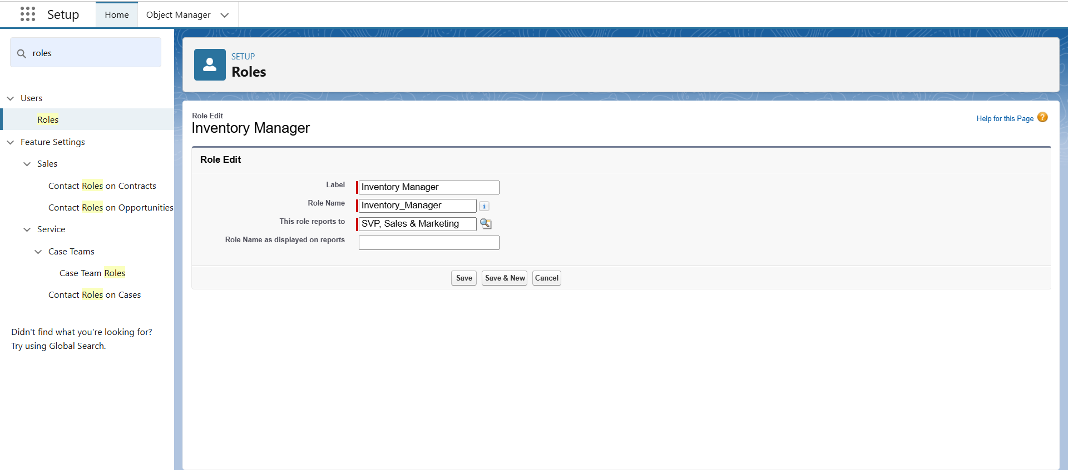

**11. Users**

* Add users and assign Roles & Profiles.
* Example:
  + *John* → Role: Purchase Manager, Profile: Purchase Manager.

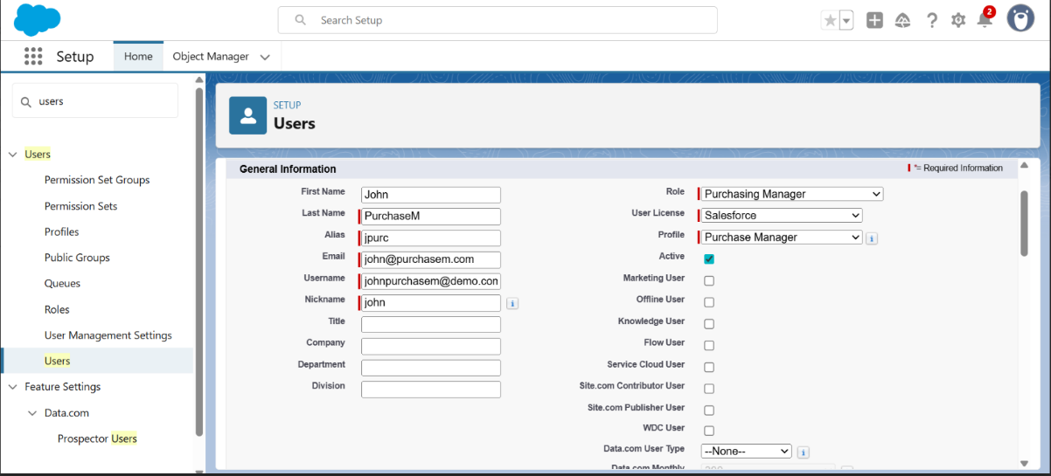

* *Ram* → Role: Inventory Manager, Profile: Inventory Manager. 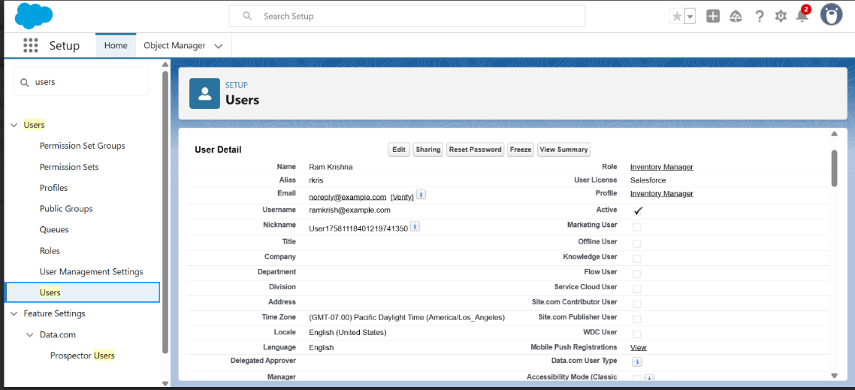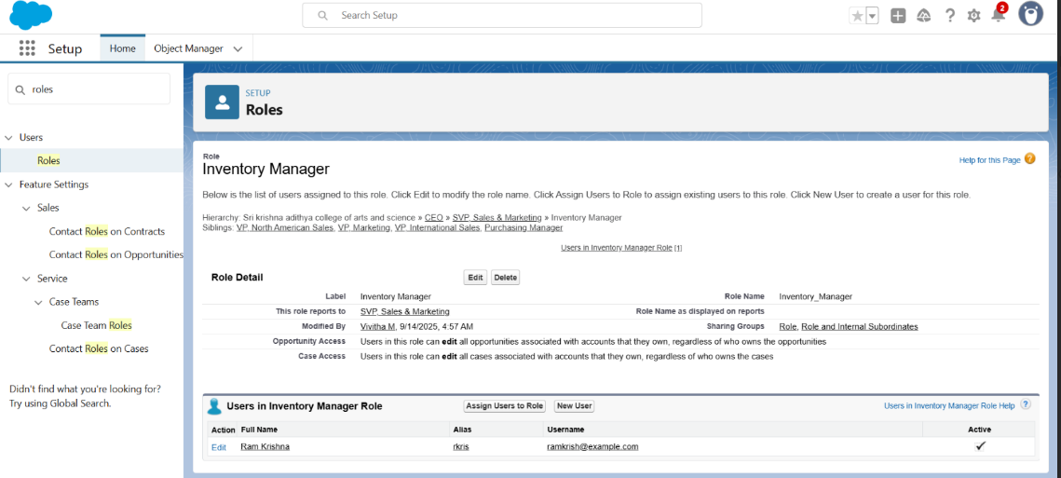
* **12. Permission Sets**
* Extra access beyond profiles. 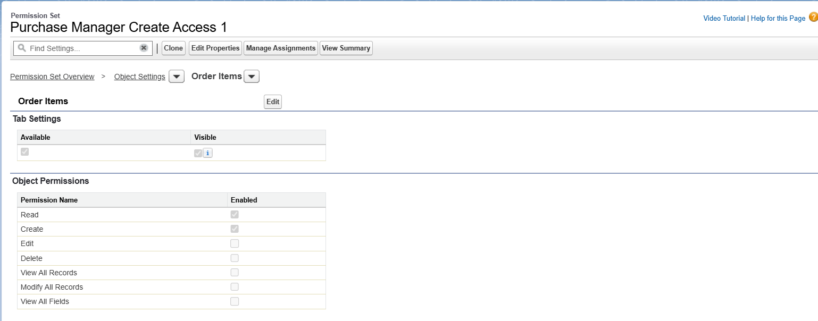

**13. Flows**

* AutomateprocessesusingFlows. 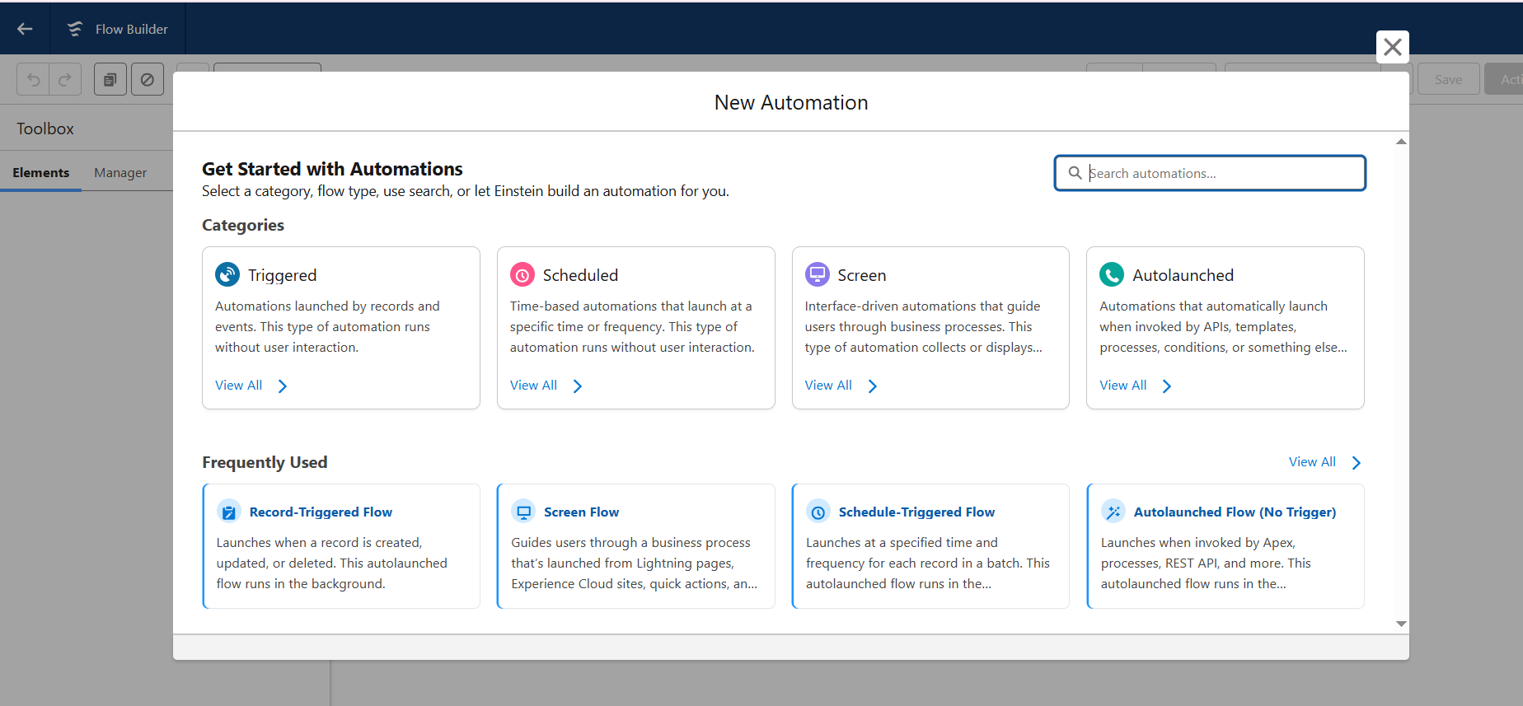
* Example: Auto-Update Actual Delivery Date = Order Date + 3 days.

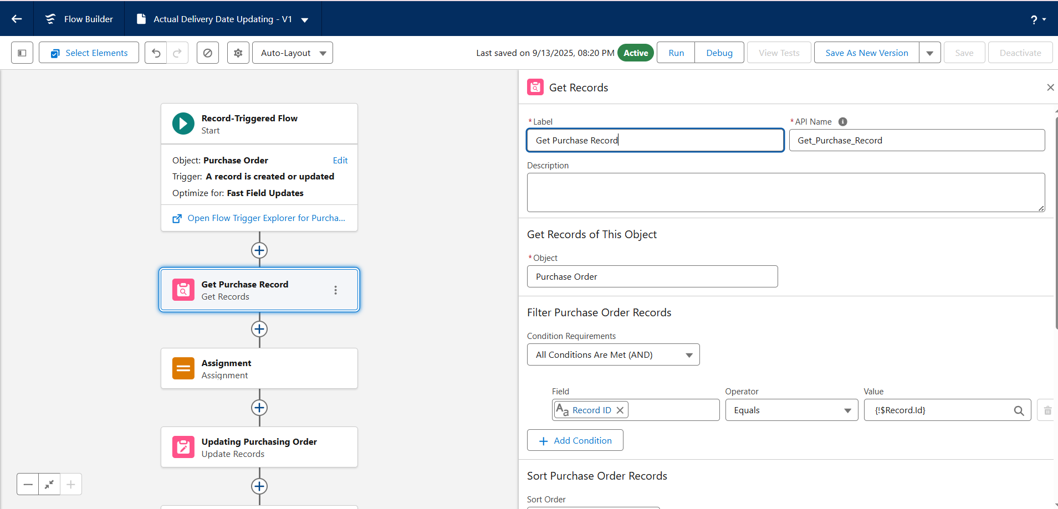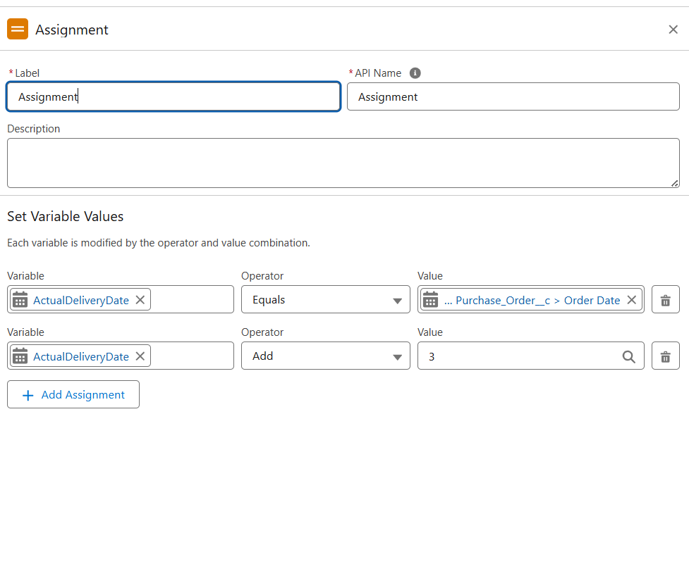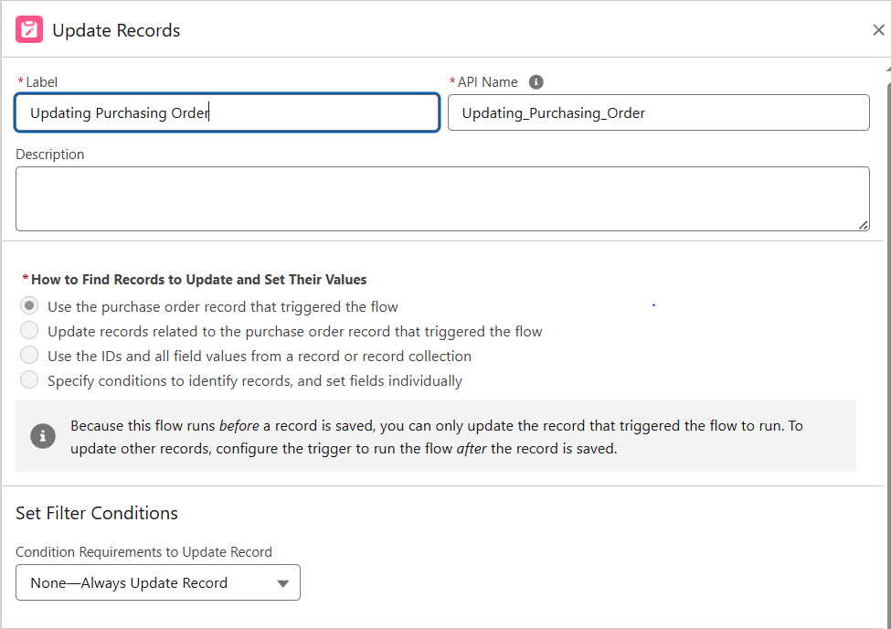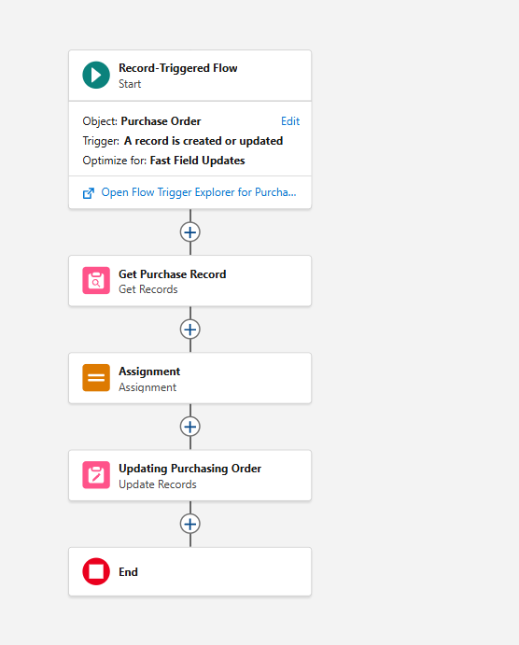

**14. Triggers**

* Use Apex Triggers for automation beyond Flows. 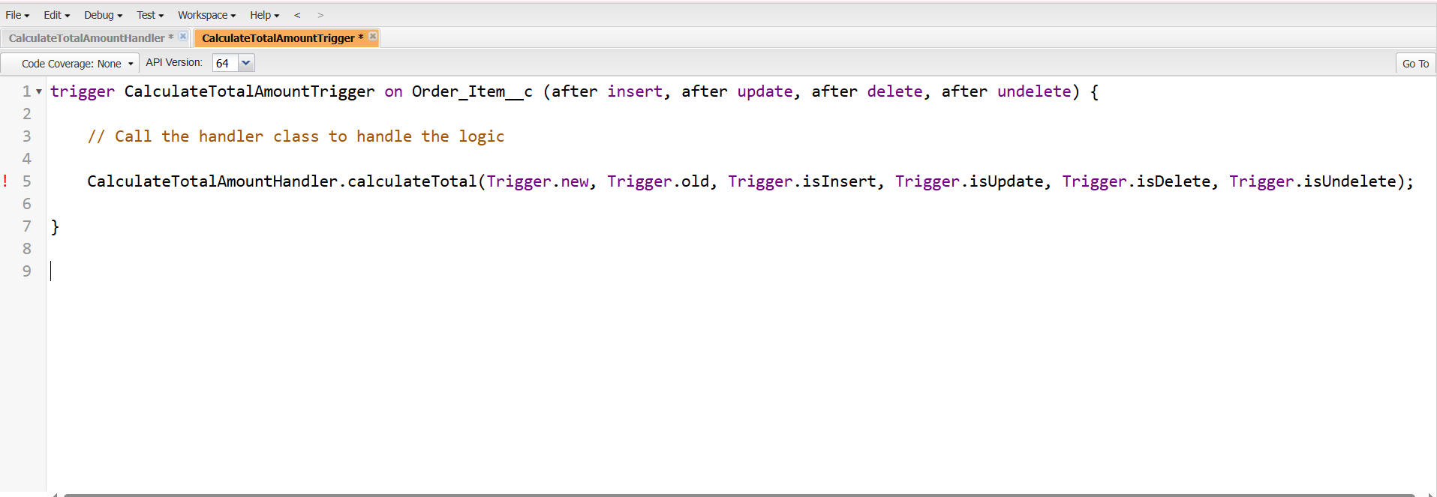
* Example: Trigger to calculate Total Order Cost from related Order Items and update PurchaseOrder. 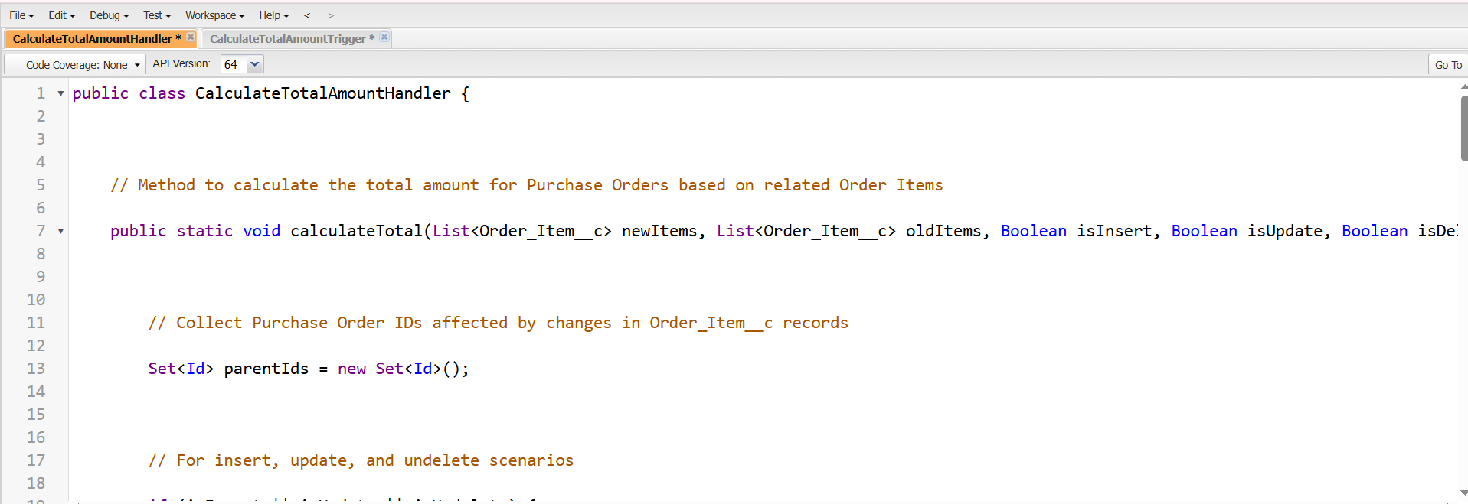

**15. Reports**

Purchase Orders by Supplier Report – Group by Supplier ID, show Total Order Cost.

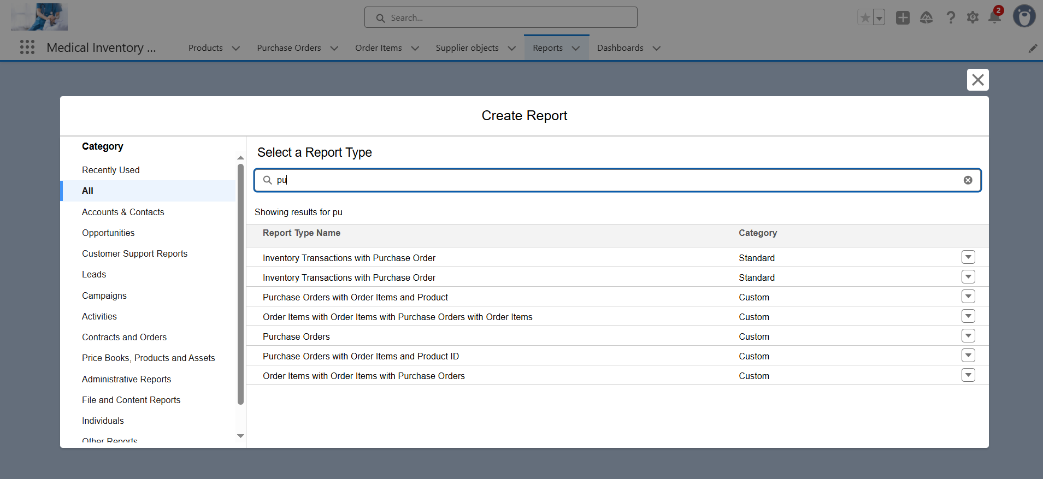

* Complete Purchase Details Report – Show Supplier, Purchase Order, Products, Quantity,Amount.

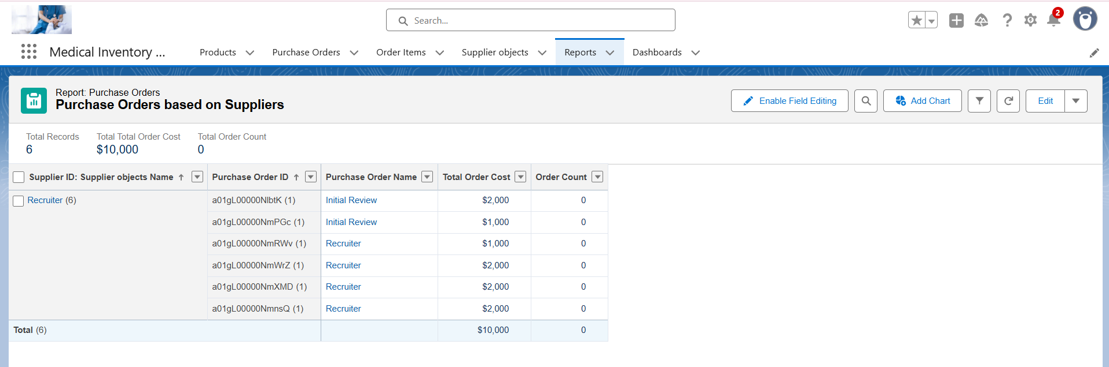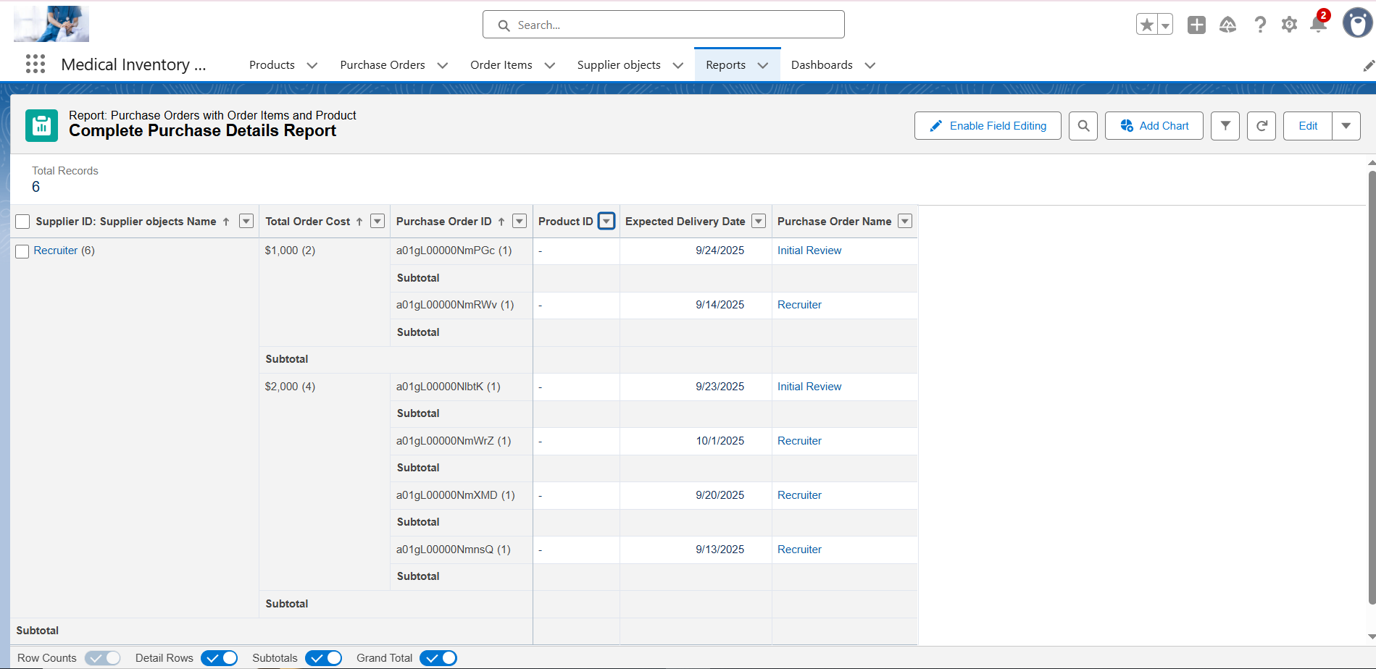

**16. Dashboards**

* Create Medical Inventory Dashboard.

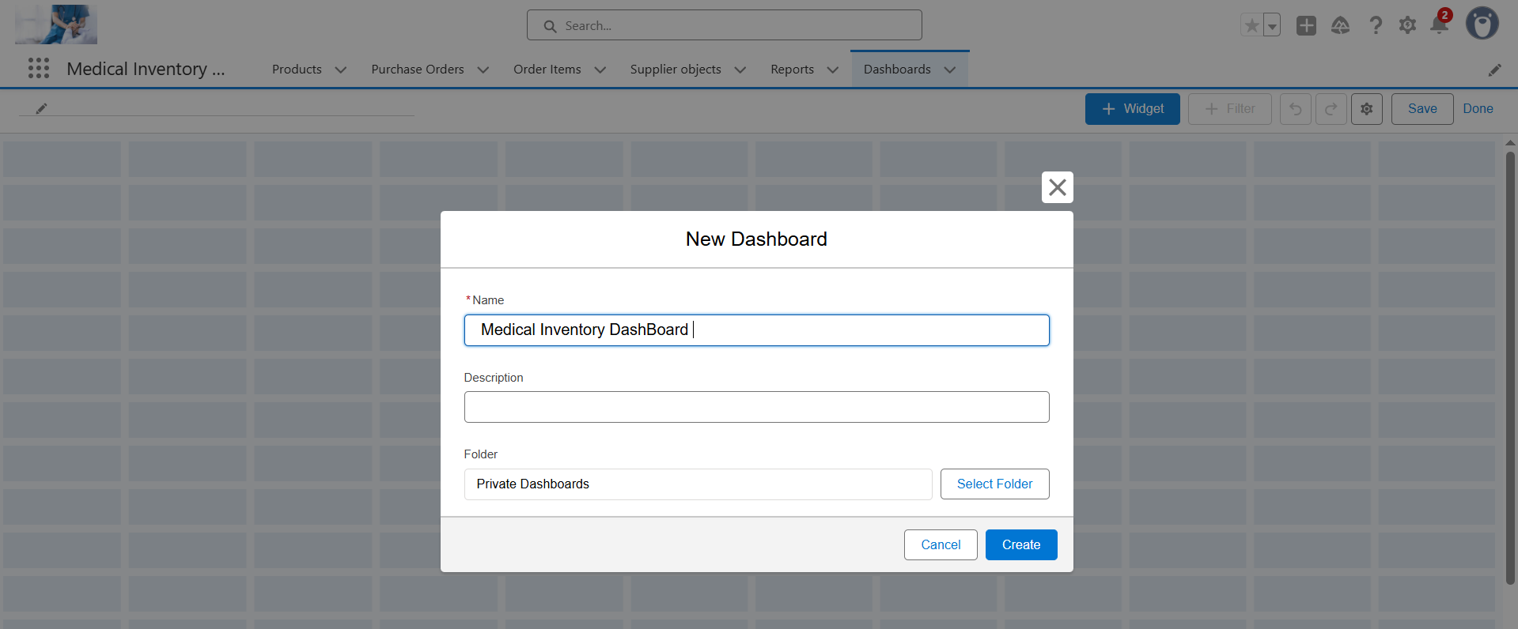

* Components: Supplier-wise Orders, Stock Status, Total Costs.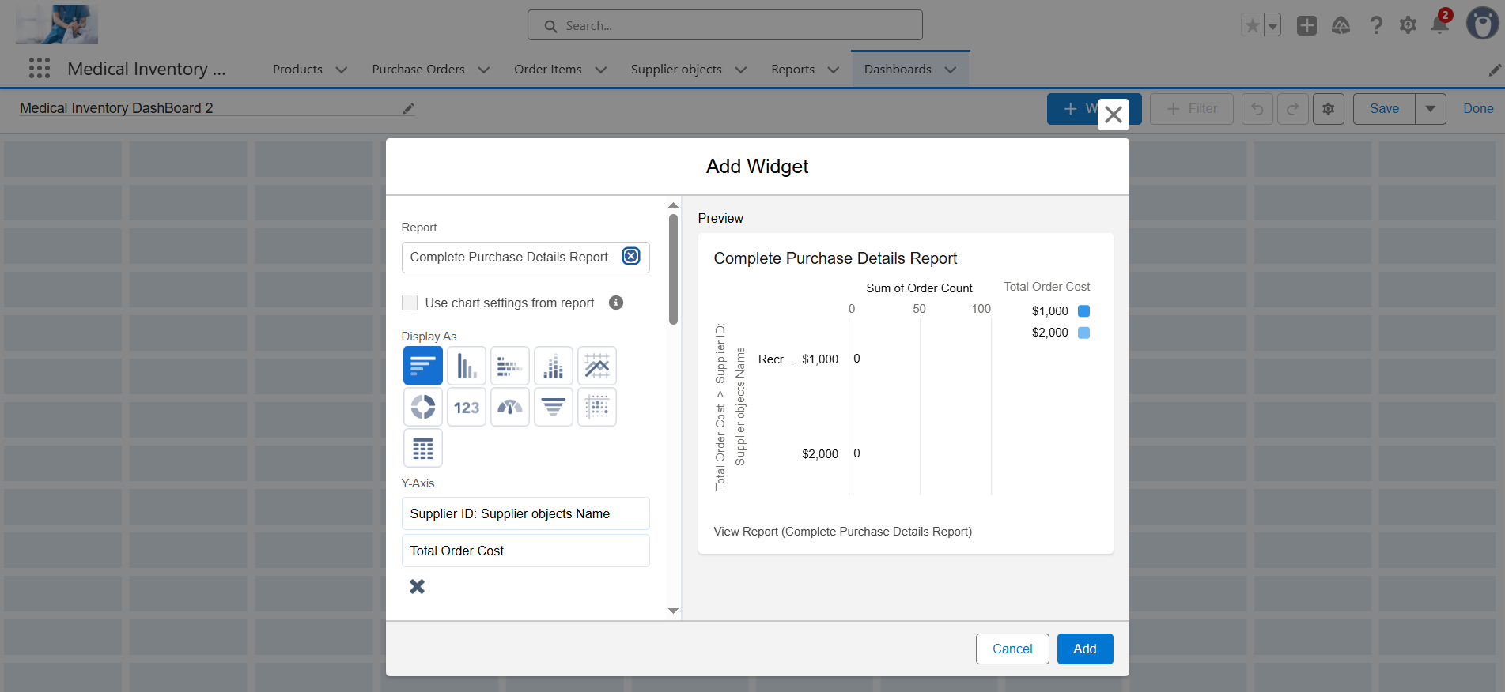

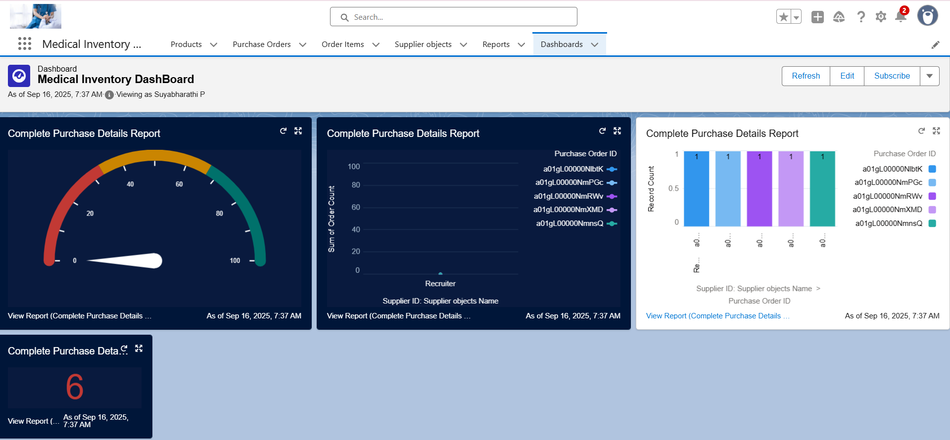

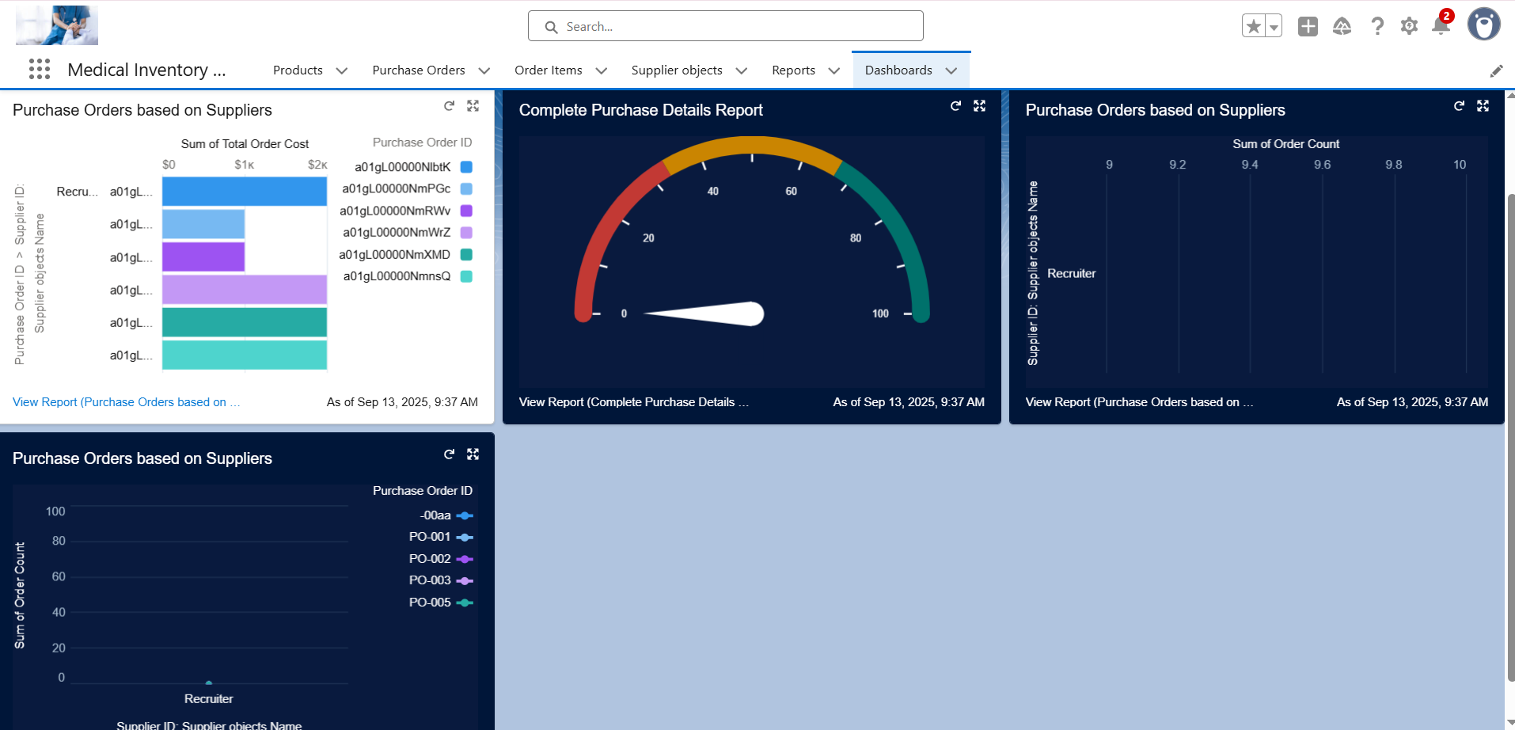

**Conclusion**

The **Medical Inventory Management System** developed on Salesforce successfully demonstrates how CRM platforms can be leveraged to manage real-time inventory operations in the medical field. By creating **custom objects, fields, validation rules, flows, triggers, reports, and dashboards**, the project ensures accurate tracking of suppliers, products, purchase orders, and inventory transactions.

**Project Achievements:**

* Created a streamlined system for supplier and purchase order management.
* Automated order tracking and product stock updates using Flows and Triggers.
* Implemented strong security using Profiles, Roles, and Permission Sets.
* Generated real-time insights through Reports and Dashboards.

**Student Learning Outcomes:**

* Hands-on Salesforce CRM skills in a real-time use case.
* Ability to design custom objects, automation, and security models.
* Improved teamwork and collaboration in managing project lifecycle.
* Exposure to industry practices in CRM and inventory management.

**Future Scope:**

* Integration with barcode scanners for product entry.
* Mobile App support for order approvals and supplier management.
* Advanced AI-driven demand forecasting and stock optimization.
* Multi-branch scalability for large healthcare organizations.